**(This word doc. may not include all screenshots and scripts. In case I missed any, please check my other documents)**

**Bikes Database Diagram**



**DimCustomer Data Flow Chart + Other Relevant Screenshots**

***Data Flow Chart for DimCustomer***

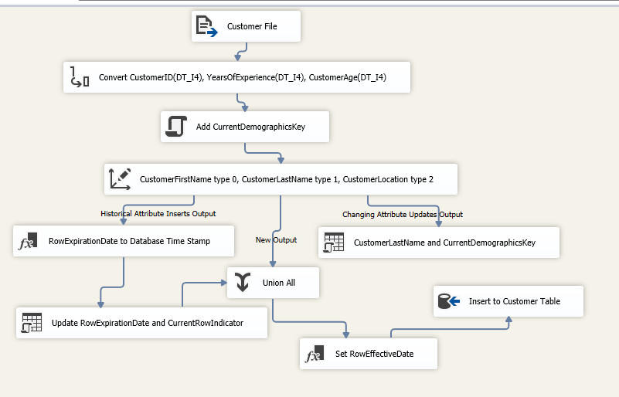

***Codes for DimCustomer***

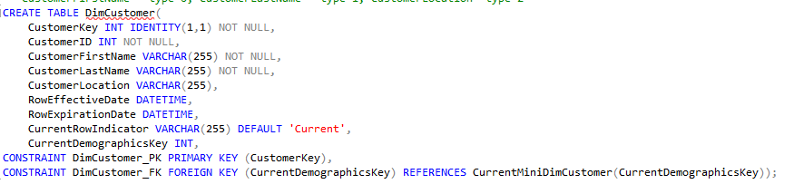

***Codes for CurrentMiniDimCustomer***

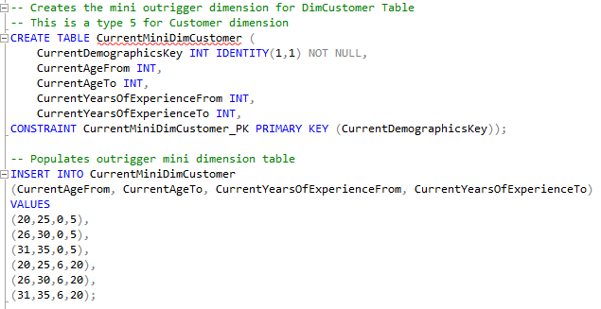

***Customer Table Flat File***

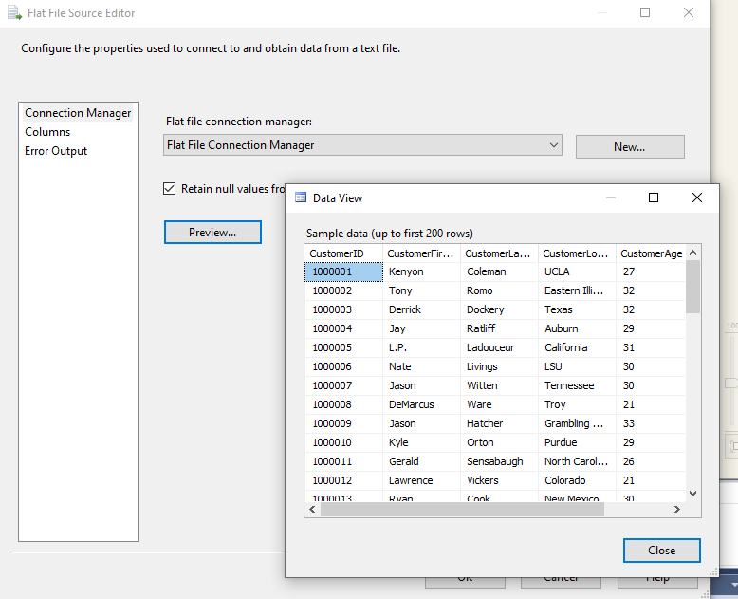

***Customer Table Data Conversion Tool***

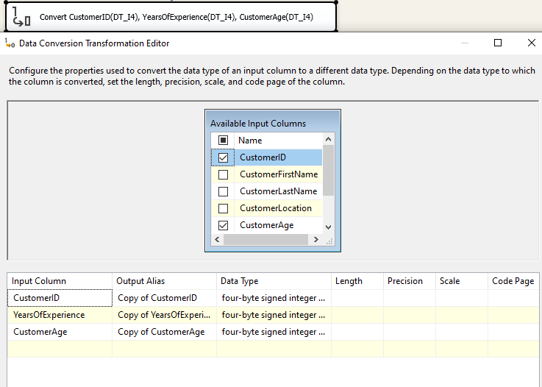

***Customer Table CurrentDemographics Key Sorting Script***

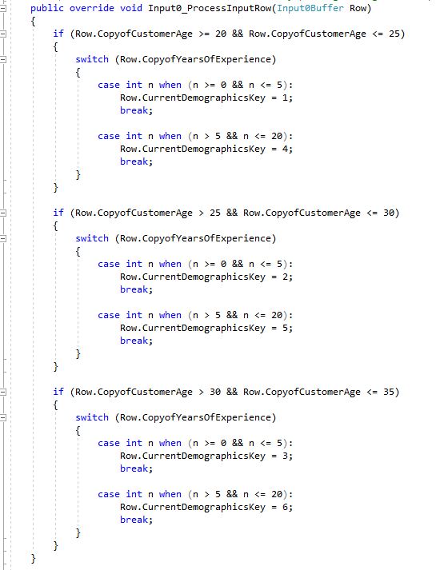

***Slowly Changing Dimension Tool for Customer***

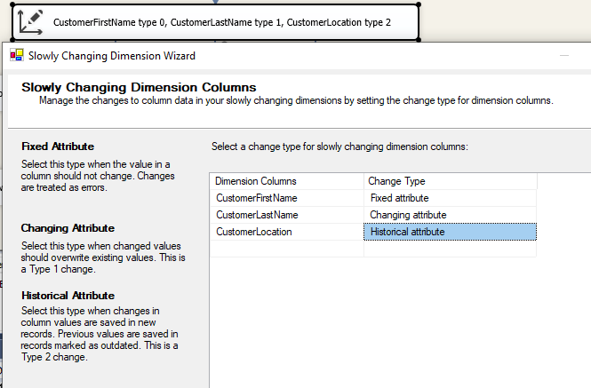

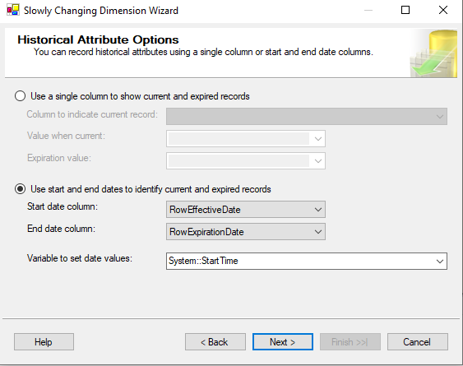

***Derived Table for Customer Table (Historical Attributes)***

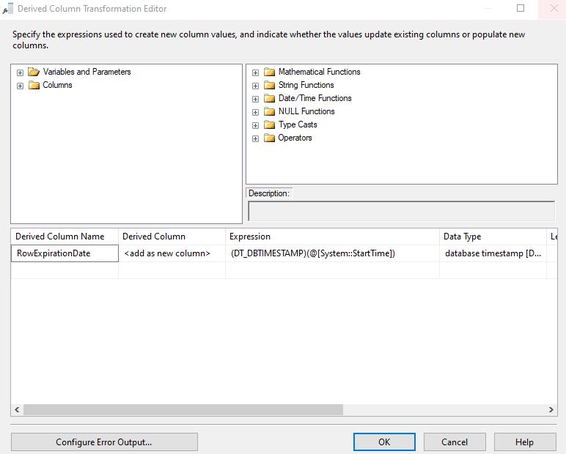

***SQL Codes for Historical Attribute in Customer Table***

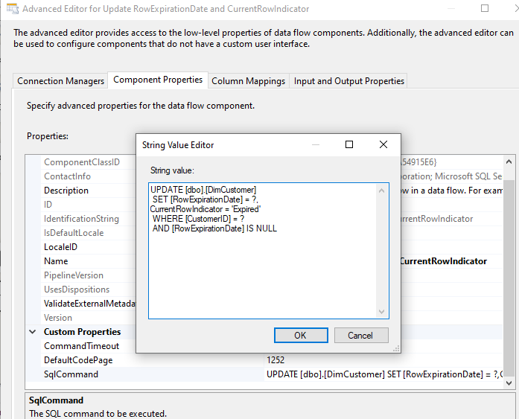

***SQL Codes for Changing Attribute in Customer Table***

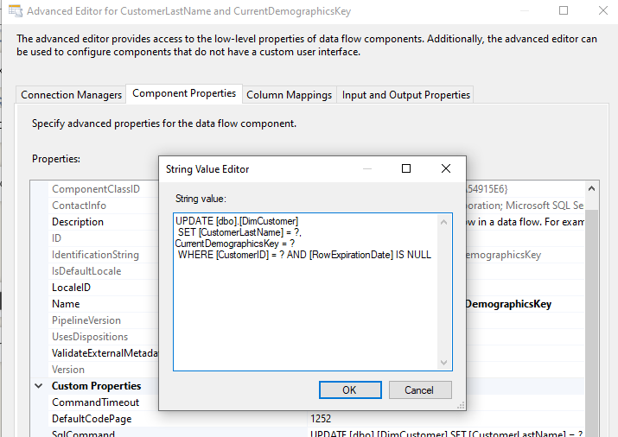

***Input Column Mapping in OLE DB Destination Tool for Customer Table***

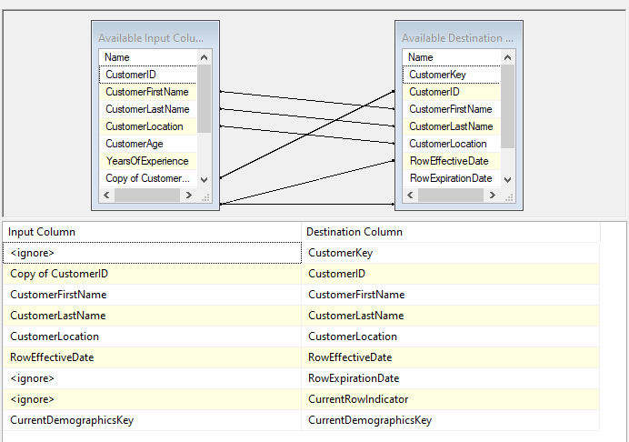

**DimProduct Data Flow Chart + Other Relevant Screenshots**

***DimProduct Data Flow Chart***

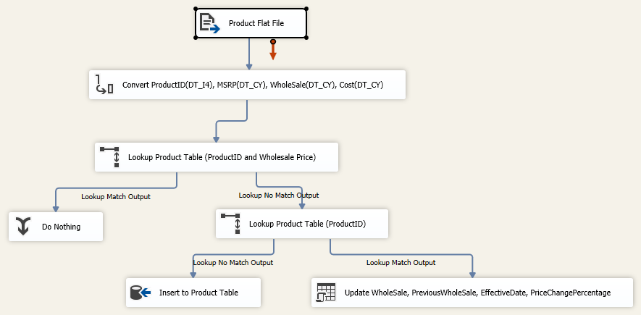

***SQL Commands for Creating the DimProduct Table***

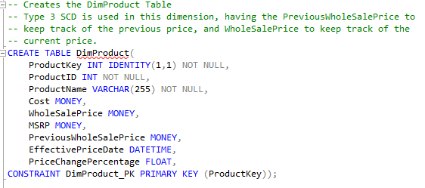

***Flat File Source Tool for DimProduct***

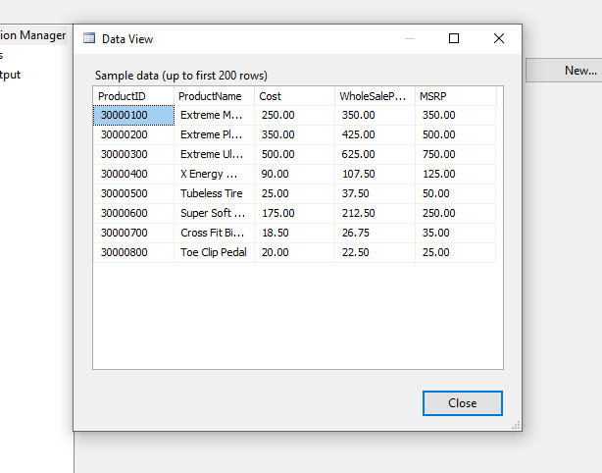

***Data Conversion Tool for DimProduct Flat File***

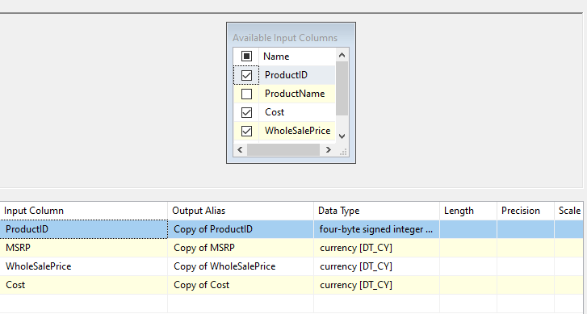

***Lookup Tool Mapping ProductID and WholeSalePrice Matches for DimProduct***

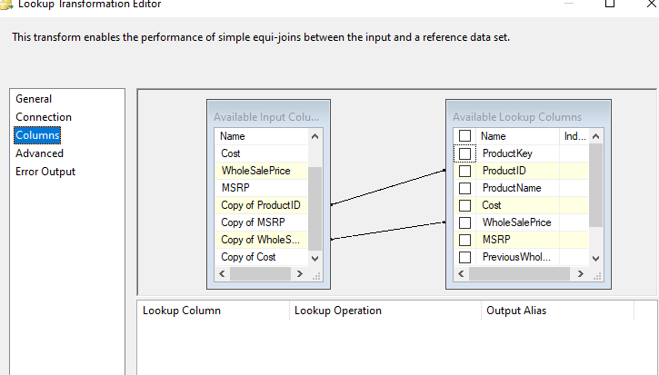

***Lookup Tool Mapping ProductID Matches for DimProduct***

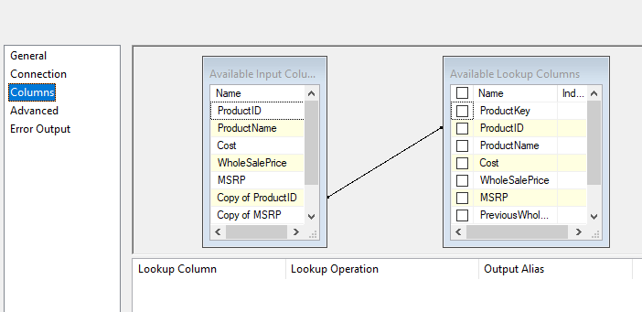

***SQL Commands for Updating Type 3 Columns of DimProduct***

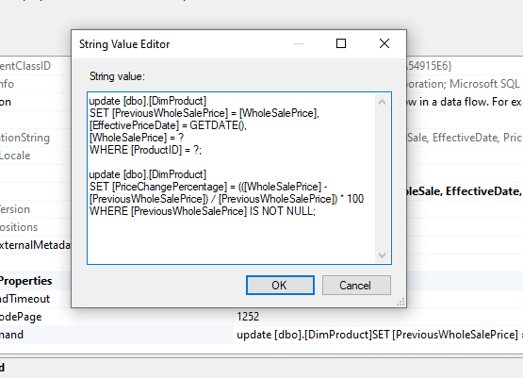

***Input Column Mapping in OLE DB Destination Tool for Product Table***

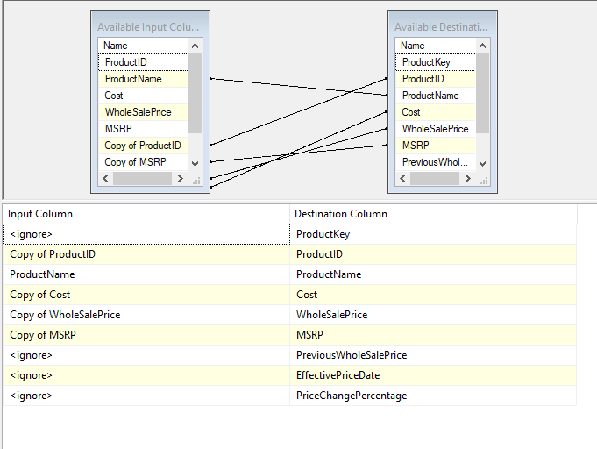

**DimEmployee Data Flow Chart + Other Relevant Screenshots**

***DimEmployee Data Flow Chart***

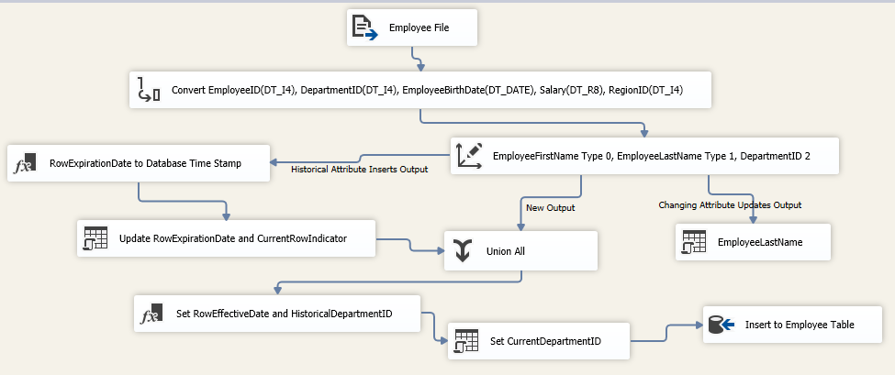

***SQL Commands for Creating the DimEmployee Table***

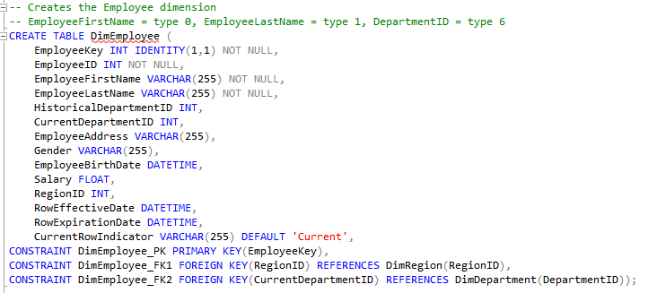

***Flat File Data of Employee Table***

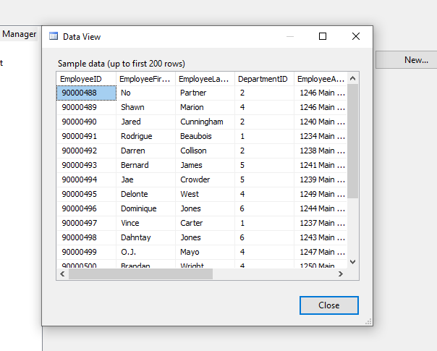

***Conversion of Employee Table Flat File Strings to Suitable Data Type***

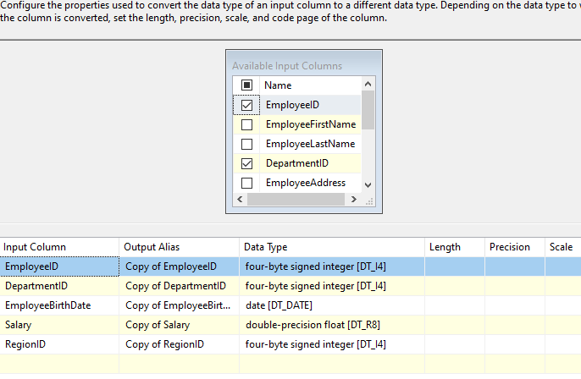

***Slowly Changing Dimension Tool For DimEmployee***

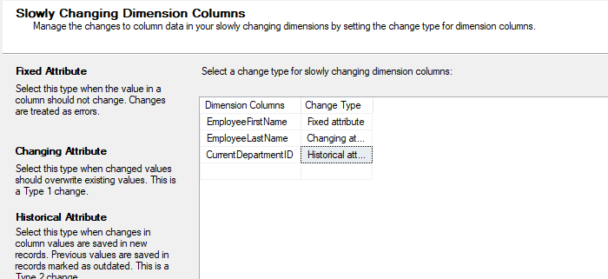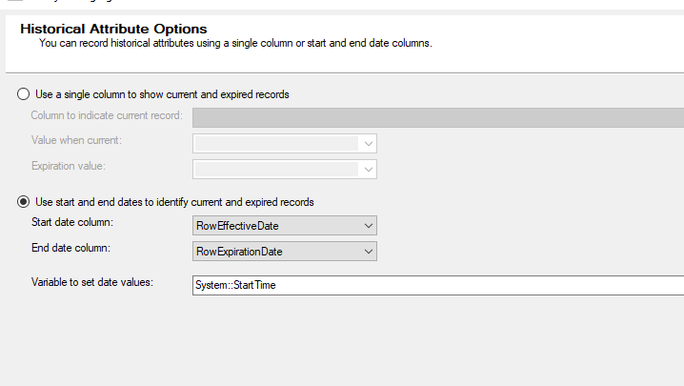

***Derived Column for RowExpirationDate Column for Employee***

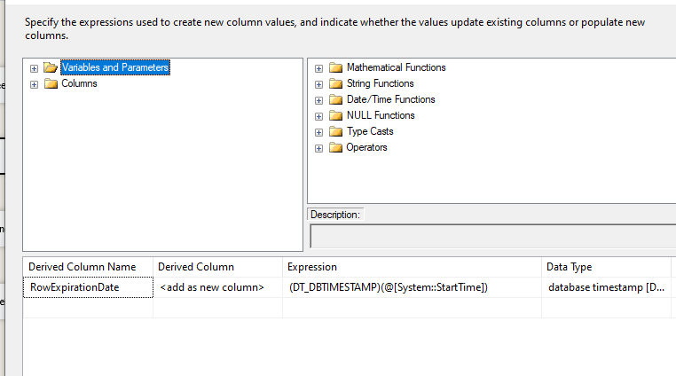

***SQL Commands for CurrentRowIndicator for Employee***

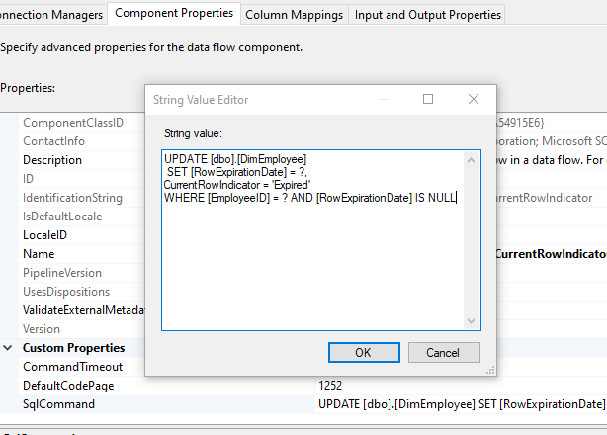

***SQL Commands for EmployeeLastName***

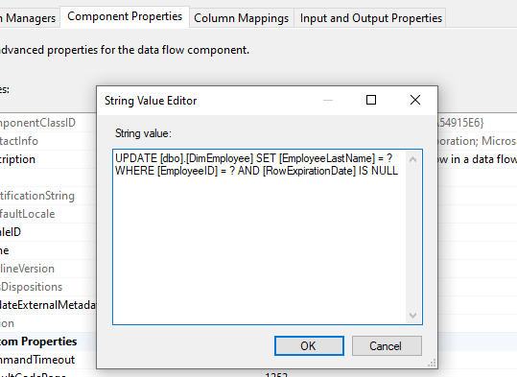

***SQL Commands for Setting CurrentDepartmentID for each Row***

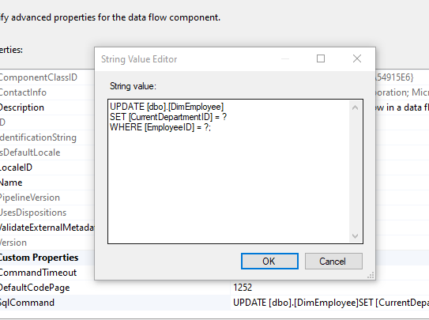

***OLE DB Destination Tool Mapping for DimEmployee***

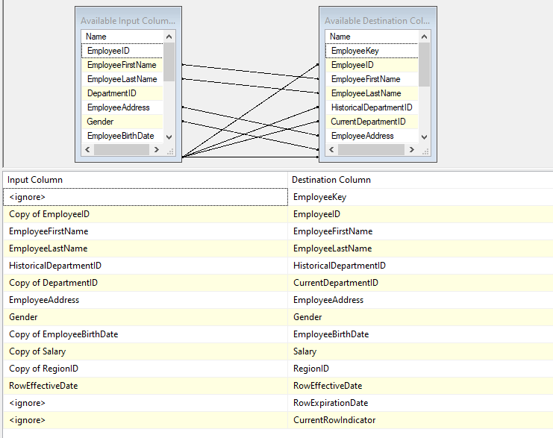

**FactSalesOrder Data Flow Chart + Other Relevant Screenshots**

***FactSalesOrder Data Flow Chart***

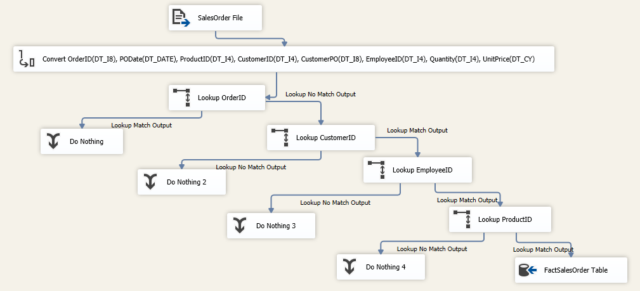

***SQL Commands for Creating the FactSalesOrder Table***

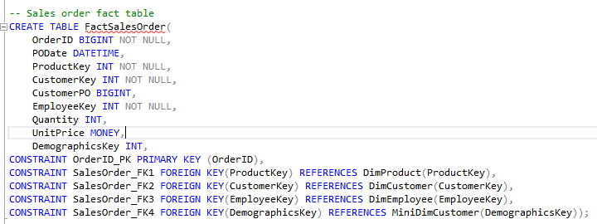

***Flat File Source of SalesOrder***

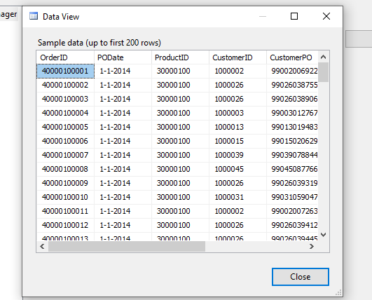

***Converted Attributes Using the Data Conversion Tool***

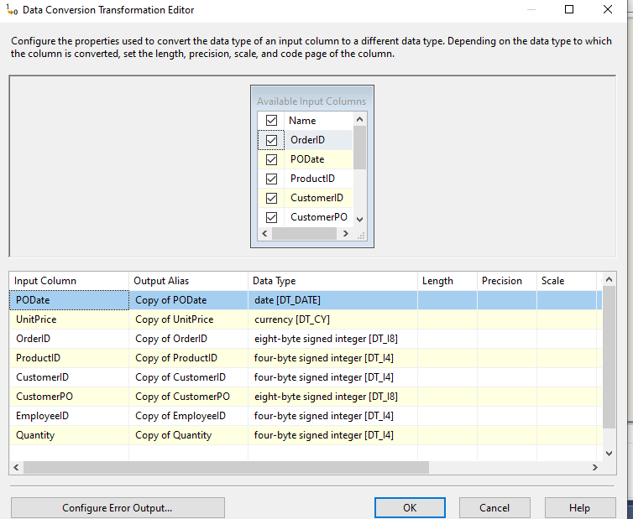

***Lookup Tool Matching the OrderID for the FactSalesOrder Table***

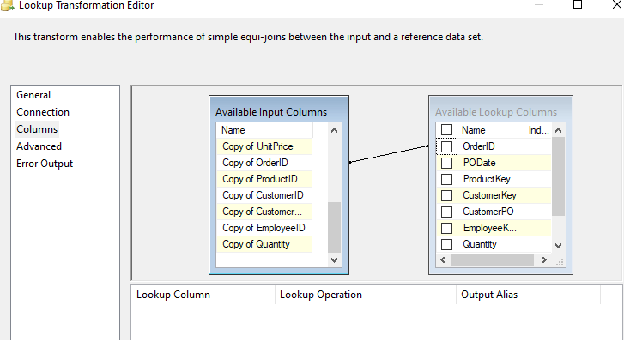

***Lookup Tool Isolating a Subset from the DimCustomer Table***

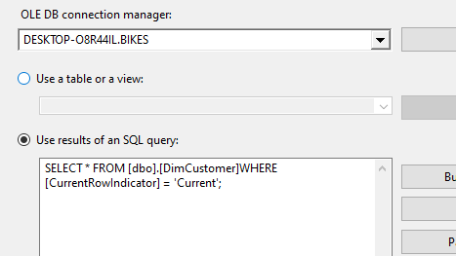

***Lookup Tool Matching the CustomerID Attribute***

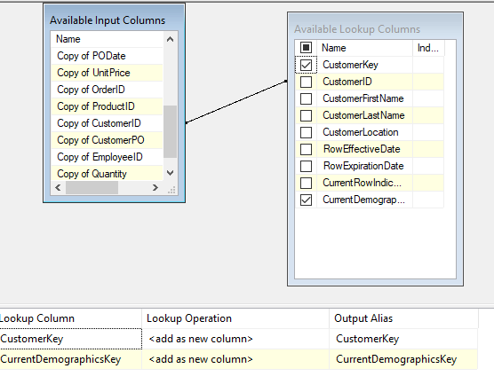

***Lookup Tool Isolating a Subset from the DimEmployee Table***

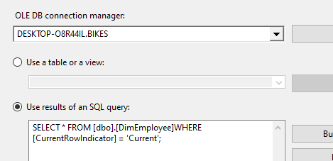

***Lookup Tool Matching the EmployeeID Attribute***

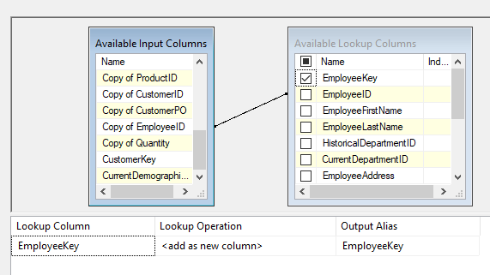

***Lookup Tool Matching the ProductID Attribute***

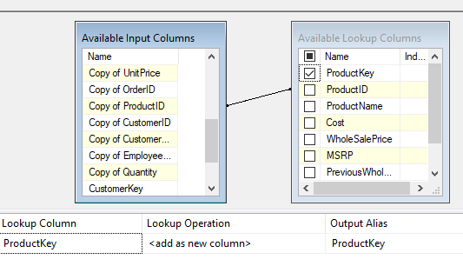

***OLE DB Destination Tool Mapped Attributes for FactSalesOrder Table***

